**UNIFORM ORDER FORM**

|  |  |  |
| --- | --- | --- |
| **Name of Pupil:** | **Tutor Group:** | **Date:** |

**Polo Shirts**

All items ordered will come with The Hub School logo on them.

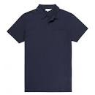Easy-care 65% Polyester 35% Cotton

|  |  |  |  |
| --- | --- | --- | --- |
| **SIZES** | **Cost** | **Quantity** | **Total Costs** |
| 9-10 yrs | £7.50 |  |  |
| 11-13 yrs | £7.50 |  |  |
| XS | £7.50 |  |  |
| Small | £7.50 |  |  |
| Medium | £7.50 |  |  |
| Large | £9.00 |  |  |
| XL | £9.00 |  |  |
| 2XL | £9.00 |  |  |

**________________________________________________________**

**Sweater Shirts**

All items ordered will come with The Hub School logo on them.

[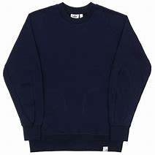](https://www.bing.com/images/search?view=detailV2&ccid=A/KcQ5hl&id=ABE5B675D79AA2BCE27A41AB03A0F5C75608A97F&thid=OIP.A_KcQ5hl0RxtwsaV7sXlEgHaHa&mediaurl=http://stormfashion.dk/uploads/products/storm/sweatshirt-adidas-xbyo_adidas-xbyo_knitwear-sweatshirts_storm_5.jpg&exph=1600&expw=1600&q=sweatershirts&simid=608055767003235403&selectedIndex=62)Easy-care 80% Polyester 20% Cotton

|  |  |  |  |
| --- | --- | --- | --- |
| **SIZES** | **Cost** | **Quantity** | **Total Costs** |
| 9-10 yrs | £9.75 |  |  |
| 11-13 yrs | £9.75 |  |  |
| XS | £9.75 |  |  |
| Small | £9.75 |  |  |
| Medium | £9.75 |  |  |
| Large | £12.00 |  |  |
| XL | £12.00 |  |  |
| 2XL | £12.00 |  |  |

**UNIFORM ORDER FORM**

**¼ Zip Fleece**

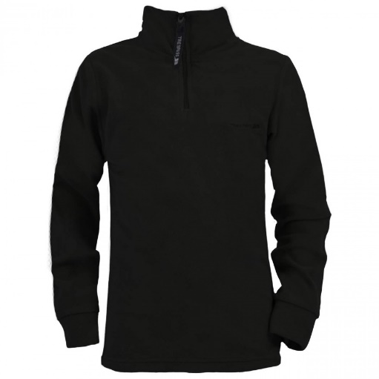All items ordered will come with The Hub School logo on them.

Easy-care 100% polyester

|  |  |  |  |
| --- | --- | --- | --- |
| **SIZES** | **Cost** | **Quantity** | **Total Costs** |
| Small | £17.00 |  |  |
| Medium | £17.00 |  |  |
| Large | £17.00 |  |  |
| XL | £17.00 |  |  |
| 2XL | £17.00 |  |  |

**________________________________________________________**

**Payment Options:**

**Cash or Cheque – all cheques should be made payable to The Hub School**

**ADMIN USE ONLY**

|  |  |  |  |  |
| --- | --- | --- | --- | --- |
| Payment Details: |  | Amount Received: | Date: | Sign: |
| Receipt Number: |  | Uniform Received Date: | | Sign: |