**  
  
  
  
  
  
  
  
  
  
  
  
  
  
  
  
  
  
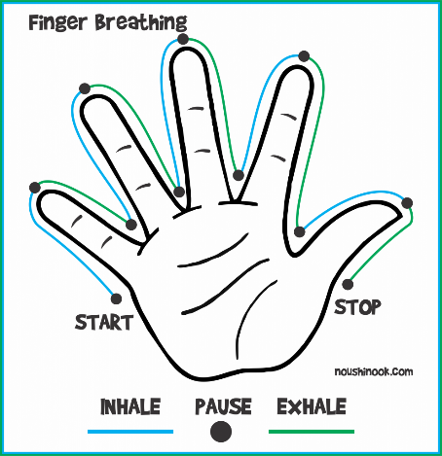  
  
  
  
  
  
  
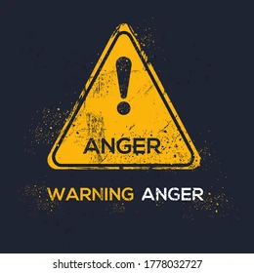  
  
  
  
  
  
  
  
  
  
  
  
  
  
  
  
  
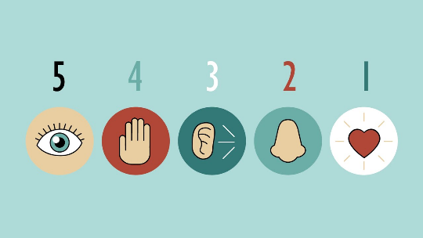  
  
  
  
  
  
  
  
  
  
  
  
  
  
  
  
  
  
  
  
  
  
  
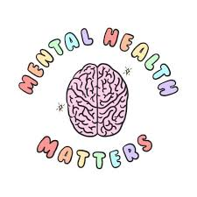  
  
  
  
  
  
  
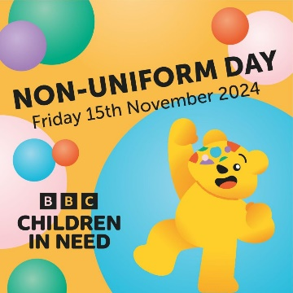**

**Why might we get angry?**

There are lots of reasons why people get angry. Sometimes it’s easy to know what triggered you. Other times you might not know why you feel that way. Here are some common reasons why people get angry:

* Past experiences
* Something that is happening in your life now
* Worries about the world
* Health and wellbeing

If you’re struggling to control your behaviour, and your anger is hurting you or other people, it’s a good idea to reach out for some support. You might need help for your anger if you’re:

* hitting or physically hurting other people or yourself
* shouting a lot at other people
* breaking stuff or throwing things
* feeling angry all the time at yourself, others or what’s going on in the world

LET’S TALK ABOUT ANGER

We all feel angry sometimes. This is a normal part of growing up and being human. Sometimes, feeling angry can be a helpful sign that something's not okay with us. It can also give us the strength and energy we need to challenge or change something.

Anger can boil over for all kinds of reasons, especially when we’re tired or stressed. It’s also a common reaction to situations that feel unfair, unsafe or out of our control. This can be the case when a young person:

* goes through big changes in their family, like their parents separating or someone dying
* experiences bullying or abuse
* experiences discrimination like racism, homophobia or ableism

**When does Anger become a problem?**It’s normal for children and young people to find it difficult to manage angry feelings sometimes. This is because the part of our brain that helps us to manage our emotions is not fully developed until our mid-20s. Teenagers also go through lots of hormone changes during puberty, which can make emotions feel more intense.

**W**orking **O**n **W**ellbeing

**How to manage your anger**

* **Breathe-**Try doing some breathing exercises before reacting
* **Hit or squeeze something soft-**Try punching a pillow, squeezing a stress ball or popping bubble wrap.
* **Write it down-**Write down everything you want to say and then throw it away or delete it.
* **Talk to someone-** Talk to someone you trust about what has made you angry.
* **Exercise-** Use exercise as a way to use your anger for good. Exercising releases positive endorphins that help to boost our mood.
* **Go to safe place-**If you have a safe place at home or school, try to go here when you feel angry. This might be somewhere you feel safe but also where a trusted adult can keep eyes on you.

**Be aware;** What are the signs you notice that tell you, you are becoming Angry?

MENTAL HEALTH MYTH BUSTERS

* Anger is a negative emotion- It is not bad to feel angry, anger is a normal emotion just like any other. As long as we try to control the ways in which we express our anger, it is healthy to feel angry.
* Anger management doesn’t work-Talking about our anger can be a powerful tool to help reduce and reflect on outbursts.
* Ignoring Anger makes it go away- Ignoring any of your feelings and bottling them up can causes these feelings to be more intense and overwhelming.

**Wellbeing News**

This half term at The Hub we fundraised for Children In need and Christmas jumper day!

Children In Need-£26.31

Christmas Jumper day-£30

In addition to this-our designated MIND support worker is also providing weekly 1:1 emotional wellbeing support to 5 of our students at our Anlaby site.

We have supported 17 students with their emotional wellbeing this half term in the form of 1:1 planned sessions at our Anlaby site.

This equates to 86 hours of 1-1 emotional wellbeing sessions delivered this half term at our long-stay site.



**Form tutors (Anlaby site)**

7A-Mr Price and Miss Priestman

7B-Miss Oliveira and Mrs Ritchie-Goodrick

8A-Mr Frederick and Miss Ives

8B-Mr Branston and Mr Eastwood

8C-Mr Kingsbury and Mrs Warneck

9A-Miss Sykes and Ms Robinson

9B-Mr Tranmer and Mrs Smith

9C-Mrs Ryan and Mr Cook

10A-Mr Stanley and Mrs Vannucci

10B-Mr O’neal and Miss Hawkins

10C-Mrs Brittain and Mrs Harrison

11B-Ms Macnamara and Miss Howlett

11C-Mr Hall and Mrs Giblin

**Form Tutors (Welton site)**

SS1-Miss Anderton

SS2-Mr Walker

SS3-Mr Derrick and Mr Thomas





**Student Support Team (SST)**

Miss Mcneil-Pastoral Support (Year 6,7,8)

Mrs Mayes-Pastoral Support (Year 9)

Mrs Dewar-Pastoral Support (Year 10&11)

Mr Lawson- Pastoral support/HLTA

Miss Bird-Emotional Wellbeing Lead (Anlaby)

Mrs Rainforth-Emotional Wellbeing Lead (Welton)

**Senior Leadership Team (SLT)**

Mr Grimes-Executive Headteacher

Mr Rollo-Head of school SEMH Specialist Provision

Mrs Austin-Head of School PRU/CP

Miss Howard-Director of Learning SEND

Mrs Asvadi-Director of Learning, Behaviour and Culture

**Attendance**

Miss Stephenson-Attendance Officer

Miss Harrison-Apprentice Attendance officer

**SEND Team**

Miss Russell-SEN Team Leader

Miss Dommett-Deputy SENDCO